Title of presentation
Janusz Kowalski¹, Adrian Nowak^{1,2}, and Jane Doe²
¹AGH University of Krakow, Academic Center for Materials and Nanotechnology, Krakow, Poland

²Kyushu Institute of Technology, Research Center for Neuromorphic AI Hardware, Kitakyushu,
Japan

Please do not change the font size, line spacing, or the borders of this template.
The abstract should be no longer than one page.

Most of the active participants of digital (information) world are aware of the real costs of the digital revolution. These costs are, however, very high: both in terms of energy and materials. Currently, large data centres (usually associated with apparently “free-of-charge”¹ services like Google, Facebook, Twitter, Instagram, or Tinder) consume more electric power than large, heavily industrialised countries. The combined energy consumption related with various IT technologies currently constitutes around 10% of worlds electricity production and, according to some prognoses, will soon start to dominate over all other consumers of energy, even if the growth of energy production will keep its current rate of increase.² Furthermore, the amount of information stored in data centres all over the world is overwhelming and tools for dealing with such a large volume of data are unknown. Constantly increasing amount of data leads to the so-called ‘information black hole’ – the state in which the amount on available data is too large to be searched and processed. This state has been envisioned by Polish ingenious writer Stanisław Lem in his novel The Star Diaries.³ According to Lem, excessive data undergo a king of collapse and are destroyed. In reality, the overwhelming flood of unprocessed data, some of which may be useless, but some may be of crucial importance, which from a pragmatic point of view, is equivalent to the destruction of the data. This can be mitigated by either changes in data storage habits and policies or by new data management methodologies, including neuromorphic computing (Figure 1).
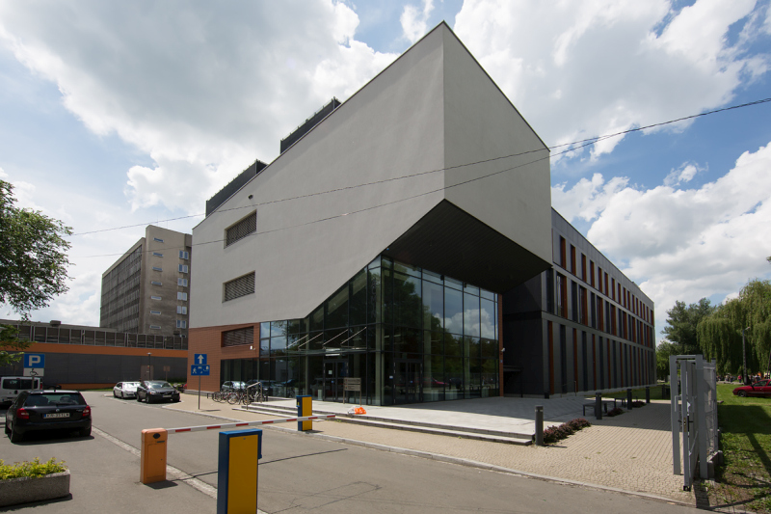
Figure 1. The ACMIN building where the symposium will be held.

Acknowledgment
This is a sample text. Authors can describe an acknowledgment as they need. If not needed, please remove this section.

References
1. D.H. Wolpert, W.G. Macready, No free lunch theorems for optimization. IEEE Trans. Evolut. Comp. 1997, 1, 67-82.
2. M.M. Vopson, The information catastrophe. AIP Advances 2020, 10 (8), 085014.
3. S. Lem, The Star Diaries. Pengin Books: London, 2021.

